Table of Contents for Software Specification Document

1. System Specification Document 2
1.1. Introduction 2
1.1.1. Purpose 2
1.1.2. Scope 2
1.1.3. Definitions, Acronyms, and Abbreviations 2
1.1.4. References 3
1.1.5. System Overview 3
1.1.6. Document Overview 3
1.2. Overall Description 3
1.2.1. Product Perspective 3
1.2.1.1. Database 3
1.2.1.2. Distribution Subsystems 4
1.2.1.3. User Interfaces 4
1.2.1.3.1. Clerk Interface 4
1.2.1.3.2. Client Interface 5
1.2.1.3.3. Manager Interface 5
1.2.1.4. Hardware Interfaces 6
1.2.1.5. Software Interfaces 6
1. 2.1.6. Communications Interfaces 6
1.2.1.7. Memory Constraints 6
1.2.1.8. Operations 6
1.2.1.9. Site Adaptation 7
1.2.2. Product Functions 7
1.2.2.1. Data Input 7
1.2.2.2. Data Processing 8
1.2.2.3. Data Output 8
1.2.2.4. Monitoring 8
1.2.2.5. Recovery 8
1.2.3. User Characteristics 8
1.2.3.1. Customer 8
1.2.3.2. Clerk 8
1.2.3.3. Manager 9
1.2.4. Constraints 9
1.2.4.1. Criticality of the Application 9
1.2.4.2. Computer Hardware Limitations 9
1.2.4.3. Computer Software Limitations 9
1.2.4.4. Communications Limitations 9
1.2.4.5. Reliability / Availability 9
1.2.5. Assumptions and Dependencies 10
1.2.5.1. Assumptions 10
1.2.5.2. Dependencies 10
1.2.6. Apportioning of Requirements 10
1.2.6.1. Customer 10
1.2.6.2. Clerk 10
1.2.6.3. Manager 11
1.3. System Specification Document Index 12

1. System Specification Document

1.1. Introduction

1.1.1. Purpose
The purpose of this document is to provide insight into the underpinnings of GPSP, (a gas pump software package,) under production and design by Equilibrium Inc.
The GPSP application will provide the service and functionality for a networked system of fueling stations. The application will achieve this functionality through use of a centralized database, end user interface for the pump, and communication between different gas distribution centers. It tracks sales and allows correlation of data between distribution centers. The data can be used to produce informative and useful reports using a report generation tool also provided by the GPSP package.
This document elaborates on the requirements and specifications for the system with varying levels of depth to facilitate familiarity with the system, complete documentation of the planning and development of the system, and a detailed reference for design and implementation of the system.

1.1.2. Scope

The scope of this document is to provide a concise, yet informative introduction and outline of general specifications and requirements to educate end users of the system, ranging from clerks to fueling station managers (Sections 1 and 2). This document will also detail the specifications and requirements further to provide a more technical explanation of the design and implementation of the software system to assist developers and programmers (Sections 3 and 4). As such, the audience of the document is wide and dynamic, serving those who use the system in day-to-day operations, as well as those who develop and maintain it.

1.1.3. Definitions, Acronyms, and Abbreviations

Client – Person who pumps the gas into their vehicle and is the end user for the client interface.
Database – A central data receptacle that stores all information about sales of gasoline from each gasoline distribution center.
Distribution Center – Gasoline station responsible for selling and distributing gasoline.
GPSP Application - The software package that offers database software, report generation functionality and an end user interface.
Report Generator – Interfaces with the centralized database and correlates data into a useful form in order to supply information useful in decision making.

1.1.4. References

This document does not reference any other documents outside the GPSP Application project.

1.1.5. System Overview

The application allows the client to buy gasoline and pay via credit card or cash by accepting a credit card number or offering the option of paying the cashier inside. The sales information is entered into a centralized database which is used to generate distribution-specific sales reports and sales reports encompassing all distribution centers. The application also facilitates for the sale of consumable goods by employing a running inventory in the database.

1.1.6. Document Overview

This document details the system requirements for the GPSP system according to our own standards. Section 2 gives a general description of GPSP. Sections 3 and 4 provide a more detailed and technical description of GPSP.

1.2. Overall Description

1.2.1. Product Perspective

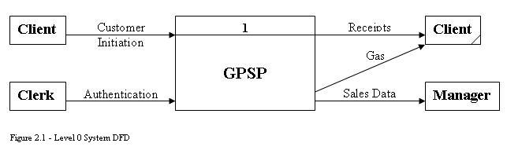

1.2.1.1. Database

The database will be a centralized software system that will collect information from all of the distribution subsystems. The database system will be located at regional headquarter locations. All distribution subsystems will get information from the centralized database to generate and display reports pertaining to sales of individual distribution centers and the entire distribution center network.

1.2.1.2. Distribution Subsystems
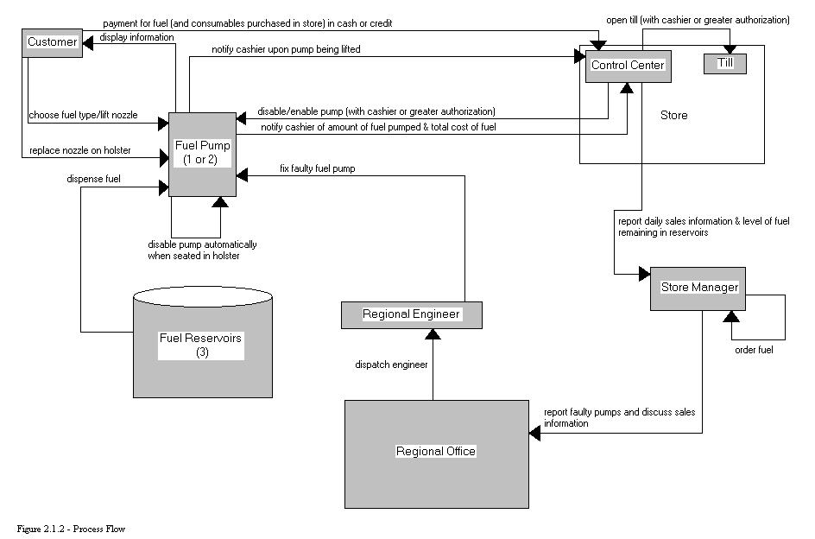

Each gasoline distribution center will have a subsystem to provide an interface with the client and in turn interface with the centralized database system. Each pump (maximum of 3 per distribution center) will have a terminal with a keypad and screen interface, which will display the client interface of the GPSP application. The GPSP application will collect information on how much gas is sold for each customer, how much the customer owes, if the customer pays and the information pertaining to the payment the customer makes (i.e. credit card number in the case of a credit card payment). Report generation software will be used by branch managers to view sales information, but multiple locations will be able to be correlated into the report generation to aid regional managers in summarizing multiple locations’ sales figures.

1.2.1.3. User Interfaces

1.2.1.3.1. Clerk Interface

The clerk interface will consist of a GUI layout including a keypad for numeric data entry (such as cash payment amount, credit card information, and product number for consumable goods inside the store) and buttons to facilitate functionality for choosing payment type, activating pumps, resetting pumps, and sending credit card information for authorization by an outside company. The interface will also provide a display box to monitor the current amount of fuel pumped for each pump, and a display box to monitor whether or not credit card information was accepted or denied.

The interface will also allow the clerk to enter a consumable item into the database. This will allow text input for product name, product number, and product price.

The interface will also provide login/logout functionality on the main screen.

1.2.1.3.2. Client Interface

The client interface will consist of a GUI layout that includes functional buttons for fuel grade selection, as well as display boxes to reflect real-time values for fuel type, the cost of fuel per gallon, the amount of fuel pumped, and the total cost for the fuel pumped as fueling continues. There will also be an initial display to instruct the client to go inside the station to establish payment.

1.2.1.3.3. Manager Interface

The manager interface will consist of a GUI layout that includes tools for report generation. The interface will provide the ability to select the following values to specify report generations:

- Date/time ranges
- Fueling station
- Fuel type
- Type of goods (fuel, consumables)
- Type of report (detailed, summary)

The interface will also have a display that shows the level of fuel for all three reservoirs, a display box to warn for low fuel capacity on each of the reservoirs, and a display for each pump that indicates a faulty state of operation.
The interface will provide simple functionality for exchanging messages with the regional office. These messages will be in text format, and will give the manager a means to order more fuel, discuss sales information, and report faulty pumps for maintenance.
The interface will also provide login/logout functionality on the main screen. Also, the interface will provide functionality to add or remove user accounts, and to organize user accounts between “clerk” and “manager” groups.

1.2.1.4. Hardware Interfaces

The database will use an HP/Compaq Proliant to host the server. The end terminals will be Dell Desktops, although virtually any modern PC will suffice. This equipment will provide the minimum functionality for our product.

1.2.1.5. Software Interfaces

The client-side software will be platform independent and will only require the platform to have a GUI and a GUI based web-browser. The database system will run on a FreeBSD operating system, it will use MySQL for all database operations and Apache for all web service applications.

1. 2.1.6. Communications Interfaces

This software will offer communication between the user interfaces and the centralized web-server/database system via the public Internet using the TCP/IP protocol encoded with SSL encryption. At each distribution center, the manager will be able to access the centralized database to create reports and activate the individual pumps ready to be activated. The client interface will also communicate with the web-server/database system. All requests will be logged and stored in the database system.

1.2.1.7. Memory Constraints

The web/database server will not require more than 256 megabytes of RAM, as it will not have to support a graphic system or high traffic volume. The only requests that should be expected will be from the distribution centers. The client side and manager side interfaces will need enough memory to support an OS with a GUI and a graphical web browser. We suggest the minimum operating system requirement for RAM on the client end, but this value will vary because the application is operating system independent on the client/manager end.

1.2.1.8. Operations

- Client initiates sale of gas by paying cashier.
- Client selects which type of gasoline to purchase.
- The attendant inside the distribution center authorizes the pumping of gas by interfacing with the centralized database and updating the sale table.
- Client pumps up to the authorized amount of gas.
- Sale is updated in the database.
- Manager checks local distribution center’s report.
- Manager checks the report for all of the distribution centers.

1.2.1.9. Site Adaptation

Each distribution center needs a computer for each pump and one computer for the clerk. The manager can use the clerk’s computer. The central web/database system will also require one computer.

1.2.2. Product Functions

1.2.2.1. Data Input

GPSP will allow for each sale to be authorized by a clerk or a credit card authority. GPSP will ask the customer for the following information:

- Type of gasoline
- Amount of gas to pump

GSPS will ask the clerk to authorize the usage of one of the pumps by entering payment information. It will also allow for the resetting of a pump in case of a drive off. The clerk will also be able to enter consumable items onto the bill of sale, as well as enter them into the database.

GPSP will allow a manager to create reports by gathering the following information:

- Which distribution centers to include in the report
- What information to include in the report
- Total amount of sales
- Type of goods
- Type of fuel
- Individual sales and times of sales
- How to separate sales (monthly, yearly, hourly)

1.2.2.2. Data Processing

All information that is input will be stored in the centralized database. Harvesting this information dynamically using the information the manager provides will generate the reports.

1.2.2.3. Data Output

GPSP will generate dynamic reports given by the options the manager selects. These options include:
- Which distribution centers’ data to include in the report
- Total amount of sales figures for each selected center
- Total amount of sales figure for all centers combined
- Separation of types of gas sold data
- Individual sales/times of sales
- Time unit to use to separate summarized data

1.2.2.4. Monitoring

Cameras will be used to monitor the cars at the pump to record any tampering or theft committed by clients.

1.2.2.5. Recovery

The central web/database system will have two backup tapes made every night to backup all transactions in case of data loss, one to be stored offsite and one to be ready in case the backup server has to be brought online. In case of server downtime, a backup server will be updated with the backup tape’s data and brought online in place of the original server.

1.2.3. User Characteristics

All users will use the same application; however, their interface will be different and be determined by a login id and password stored in the centralized database.

1.2.3.1. Customer

The customer must to be able to pay for the gas and pump the correct amount of gas.

1.2.3.2. Clerk

The clerk must be able to authorize and complete the sale of gasoline and goods, enter payment information, reset a pump on which a customer did not finish a transaction, and enter consumable goods into the database.

1.2.3.3. Manager

The manager needs report generation tools to be able to pick attributes to display reports that are important to him/her for management decisions. The manager must also be able to add, remove, and organize user accounts in the system.

1.2.4. Constraints

1.2.4.1. Criticality of the Application

The GPSP web/database system is vitally important to the entire GPSP system. If this system goes down, all branches will be offline. The end user computers are not as critical because if one goes down, it only affects the one computer that is offline.

1.2.4.2. Computer Hardware Limitations

GPSP will require a database server that can store all transactions and enough RAM to handle the transaction traffic. All end user computers and the central web/database system will need network connectivity, whether by Internet or simply a company-wide Internet (WAN). The end user computers need only standard components in order to functions properly.

1.2.4.3. Computer Software Limitations

GPSP software is limited by the amount of throughput network provides, the limitations that are put on the Apache web-server, which can be a variable amount, and the limitations on the MySQL daemon. One limitation of the GPSP software is that the clerk interface will only be able to activate and monitor at most 3 pumps concurrently.

1.2.4.4. Communications Limitations

GPSP is dependant on network communication between all working end user computers and the web/database system. Information is entered into the end user computers and the web/database system replies with its response via network connection.

1.2.4.5. Reliability / Availability

The GPSP system is only available when the centralized web/database system is online and has network connectivity to the end user systems in question. If any customer systems go offline, the outage is isolated to that particular customer node. However, if a clerk’s system goes offline, cash payments will not work at the location that the clerk’s system is arbitrating and pumps at that location will not be able to be reset.

1.2.5. Assumptions and Dependencies

1.2.5.1. Assumptions

- The system assumes that all of the gas that the user intends to pump when it is paid for.
- The system assumes that any credit card information is valid and approved.
- The system assumes that all machinery is in working order and will always function correctly, though a pump will be able to indicate if it is in a faulty state.
- The system assumes that all gas bought is available.

1.2.5.2. Dependencies

- The system is dependant on the clerk entering in the correct amount of money the client pays.
- The system is dependant on all communication, hardware and software functioning correctly.

1.2.6. Apportioning of Requirements

Each type of user will have specific requirements for usage.

1.2.6.1. Customer

- Ability to select type of payment
- Ability to select amount of gas to be pumped
- Ability to enter credit card information

1.2.6.2. Clerk

- Ability to approve the activation of a pump
- Ability to enter in payment information - i.e. credit card number or amount of cash
- Ability to reset a pump that did not complete a transaction

1.2.6.3. Manager

- Ability to select different attributes to include in a report
- Ability to view and print a selected report
- Ability to add a user account
- Ability to remove a user account
- Ability to organize user accounts between clerks and managers

1.3. System Specification Document Index

A
Apportioning of Requirements 11
Assumptions and Dependencies 11

C
client 4
Client 3
Client Interface 6
Communications Interfaces 7
Constraints 10

D
Database 3, 4
Distribution Center 3
Distribution Subsystems 5

G
Gasoline station 3
GPSP 3
GPSP Application 3

H
Hardware Interfaces 7

M
Manager Interface 6
Memory Constraints 7

P
Product Functions 8
Product Perspective 4
Purpose 3

R
Report Generator 4

S
Scope 3
Software Interfaces 7

U
User Characteristics 9
User Interfaces 5

